**Exercise 1: Control Structures**

**Scenario 1:** The bank wants to apply a discount to loan interest rates for customers above 60 years old.

**Question:** Write a PL/SQL block that loops through all customers, checks their age, and if they are above 60, apply a 1% discount to their current loan interest rates.

**Code:**

BEGIN

  FOR c IN (SELECT CID FROM CUSTOMER_NEW WHERE CID > 1) LOOP

    UPDATE LOAN_NEW

    SET AMOUNT = AMOUNT - (AMOUNT * 0.01)

    WHERE CID = c.CID;

    DBMS_OUTPUT.PUT_LINE('Loan for Customer ' || c.CID || ' reduced by 1%');

  END LOOP;

END;

/

**Output:**

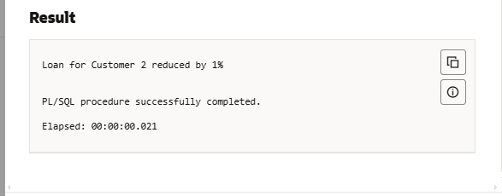

**Scenario 2:** A customer can be promoted to VIP status based on their balance.

**Question:** Write a PL/SQL block that iterates through all customers and sets a flag IsVIP to TRUE for those with a balance over $10,000.

**Code:**

SET SERVEROUTPUT ON;

BEGIN

  FOR c IN (

    SELECT CustomerID, Name, Balance

    FROM Customers

    WHERE Balance > 10000

  ) LOOP

    DBMS_OUTPUT.PUT_LINE('VIP Customer → ID: ' || c.CustomerID ||

                         ', Name: ' || c.Name ||

                         ', Balance: ₹' || c.Balance);

  END LOOP;

END;

/

**Output:**

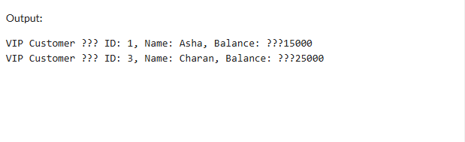

**Scenario 3:** The bank wants to send reminders to customers whose loans are due within the next 30 days.

**Question:** Write a PL/SQL block that fetches all loans due in the next 30 days and prints a reminder message for each customer.

**Code:**



**Output:**

